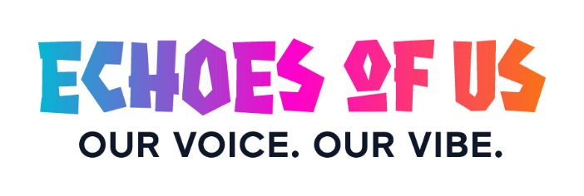

PARENT / GUARDIAN CONSENT FORM

Echoes of Us – Our Voice. Our Vibe.

CARIFESTA XV Youth Legacy Competition

About the Competition
Echoes of Us – Our Voice. Our Vibe. is the official CARIFESTA XV Youth Legacy Competition.
It invites young people to creatively reflect on their CARIFESTA XV experience and Caribbean identity through writing, music, and multimedia.
The competition forms part of the CARIFESTA XV Legacy Programme, which preserves the voices, stories, and creative expressions of Caribbean youth beyond the festival.
Students who participated in the CARIFESTA XV Youth Jamboree are eligible to enter specific categories of the competition.

Eligibility for Student Jamboree Participants
With parental or guardian consent, students under 18 years of age may participate in the following categories:
- Literary Exposition (essay, poetry, or short story)
- Songwriting / Composition (original song and lyrics)
(The Multimedia category is open regionally to youth under 21.)

Purpose of This Consent
This consent form authorises your child/ward to:
- Participate in the Echoes of Us – Our Voice. Our Vibe. competition
- Submit original creative work for judging and evaluation
- Be considered for prizes, awards, and public recognition
Selected entries may be:
- Showcased at live or virtual events
- Featured on official CARIFESTA platforms
- Included in the CARIFESTA Youth Legacy Digital Archive or Anthology
All works will be credited to the student creator.

Nature of Participation
Participation involves creative submission only (writing, music, or digital content).
There are no physical activities or physical risks associated with this competition.
Participation is voluntary, and no fees are required to enter.

PARENT / GUARDIAN CONSENT & DECLARATION
I, the undersigned parent/legal guardian, give permission for my child/ward to participate in the Echoes of Us – Our Voice. Our Vibe. – CARIFESTA XV Youth Legacy Competition
I confirm that:
- My child’s submission will be original work created by the student
- I understand the competition categories, judging process, and awards structure
- I consent to the non-commercial use of my child’s work for educational, cultural, archival, and promotional purposes related to CARIFESTA XV and its legacy initiatives
- My child will retain authorship credit for their work at all times
- I understand that consent may be withdrawn in writing prior to the judging phase

Student Information
- Student Name: ______________________________________
- Date of Birth: ______________________________________
- Age: __________
- School: ____________________________________________
- Country: __________________________________________
- Competition Category (tick one):
☐ Literary Exposition
☐ Songwriting / Composition

Parent / Guardian Information
- Full Name: _________________________________________
- Relationship to Student: _____________________________
- Telephone: ________________________________________
- Email: ____________________________________________

Consent Confirmation
I have read and understood the information above and hereby grant consent for my child/ward to participate.
- Parent / Guardian Signature: _________________________
- Date: _____________________________________________

Submission Requirement
This signed consent form must be submitted with the student’s competition entry if the participant is under 18 years of age.

